This is an excerpt derived from pages 3-19 of John Belton’s *American Cinema/American Culture*

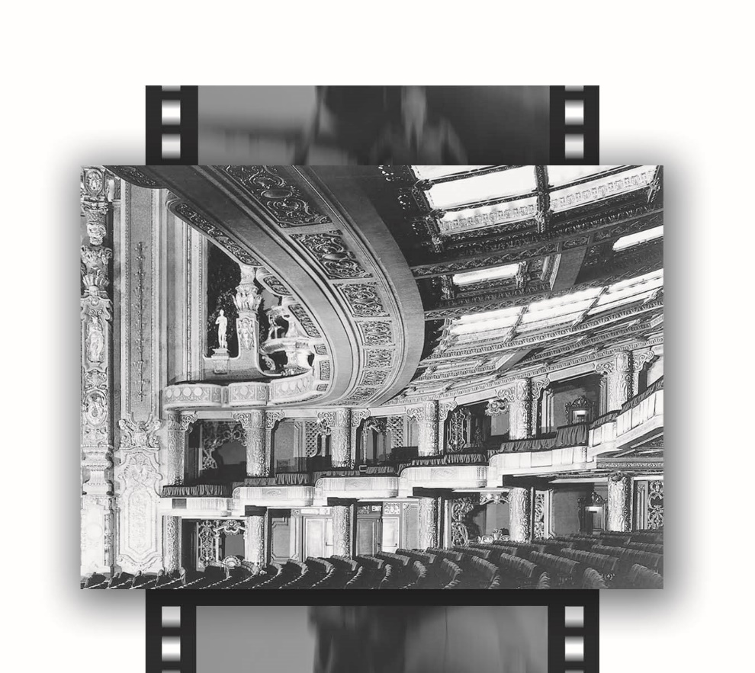

*The Emergence of the Cinema as an Institution*

“THE CATHEDRAL OF THE MOTION PICTURE”

For the better part of the last century, the movies enjoyed a unique status as the premier entertainment activity for the majority of Americans. The movies, like baseball, became something of a national pastime. Americans not only supported their motion pictures but loved them as well. Going to the movies, though perhaps not a religious experience for most, was certainly an ecstatic experience for many. Ecstasy came not only from the movies themselves but also from the surroundings in which they were presented.

Movie palaces built in the 1910s, 1920s, and 1930s resemble gigantic cathedrals. Indeed, the 6200-seat Roxy, the world’s largest theater, was described in advertisements as “the cathedral of the motion picture.” Spectacular theaters like the Roxy inspired awe, and this awe inspired, in turn, cartoons like that in the *New Yorker* in which a little girl, staring in amazement at the interior of a theater lobby, asked, “Mama—does God live here?” The cult status of movies extended to those who appeared in them. Movie fans helped to transform charismatic screen actors and actresses into movie stars, making them the objects of intense popular fascination and even idolization. Although mass-produced, movies have recovered a certain sense of aura or at least a unique sense of novelty and excitement for consumers of mass culture. Unlike preindustrial forms of entertainment such as the theater, the things represented (the characters, the story) were not really there before the audience. Instead, they were only there indirectly; they were present in the form of images on the screen. Although they were mechanically reproduced, they nonetheless continued to create an impression of immediacy and presence. At any rate, audiences regarded them as special. They waited for hours in lines several blocks long to see new films that had been highly publicized or critically acclaimed, were controversial—or that merely featured their favorite stars.

For twenty years, from the coming of sound in 1929 to the postwar period (1949), roughly 80 to 90 million Americans went to the movies *every week.* In other words, virtually every American between the ages of 6 and 60 went to the movies at least once a week. Although certain films, like *Gone With the Wind* (1939), drew more viewers than others, movie going had become a habit and increasing numbers of spectators religiously went to see whatever was playing at their neighborhood theaters. Though the movies may have resembled a religious institution, they were always primarily a social institution—going to the movies became a way in which people passed their leisure time. However, in even the most common sense of the term, by the 1920s the cinema had definitely become an institution—an integral feature of the experience of being an American in the twentieth century. Going to the movies became as commonplace as going to school, to work, or to church. For earlier generations, it was as familiar an activity as watching television, checking email, playing video games, or tweeting is today.

DEVELOPING SYSTEMS:

SOCIETY AND TECHNOLOGY

The cinema is an institution in a number of senses of the term. It is an economic institution, designed to make money. In order to do this, it established itself as an industry. It is a complex organization of producers, distributors, and exhibitors whose job it is to make and market motion pictures. To accomplish its goals, the industry developed a basic technology that facilitates the production and exhibition of movies. It also established various systems—such as the star system (see Chapter 5) and the genre system—which are designed to ensure that individual films return a profit to the industry that produces, distributes, and exhibits them. Stars and genres serve as known commodities that guarantee, up front, a certain minimal amount of pleasure that can be expected by viewers. Thus, in addition to the basic technological machinery required for making and showing films, the industry developed a secondary, “mental” machinery that makes audiences want to go to the movies.

An advertisement for a new movie palace, the Paramount Theatre, described it as “the playground of the millions, in a Palace worthy of a King.”

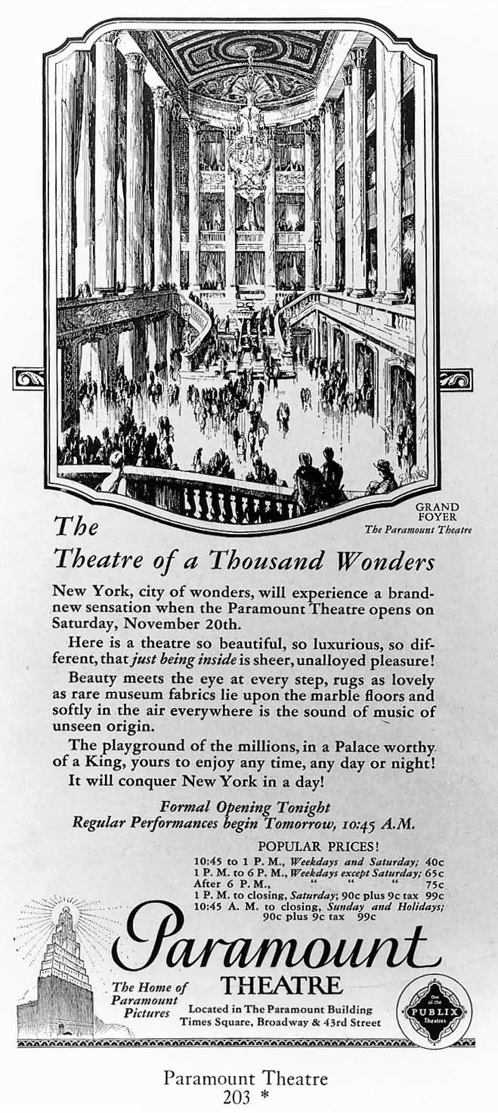

Author’s collection

In other words, the cinema, as an institution, developed on a variety of different levels at the same time. It functions as a social institution. That is, it is a means of providing an appropriate form of social contact for members of an emerging American populace born and bred in the world of mass culture. Indeed, it became an even more appropriate and more modern forum for leisure-time communal activity, for example, than were previous working class social institutions such as churches, dance halls, social clubs, and saloons, which belong more properly to an earlier, preindustrial culture. At the same time, the cinema evolved as a technological institution that became dependent for its success on products of the Industrial Revolution—cameras, celluloid, microphones, amplifiers, magnetic recording tape, fi lm laboratories, electricity, projectors, speakers, and screens. And it serves as a psychological institution whose purpose is to encourage the movie going habit by providing the kind of entertainment that working-class and middle-class Americans want.

The cinematic institution has changed from period to period, responding, in part, to technological changes, to the changing demands and leisure-time activities of audiences, and to social and economic changes that take place in American culture as a whole. But these changes have taken place within a more or less fixed notion of the cinema’s identity as a medium. For roughly a hundred years, no matter how often the face of the cinema has changed, the underlying structure of the cinematic experience has remained more or less the same. Going to the cinema has consisted of watching life-size images projected on a big screen.

Yet even this fundamental feature of the cinema’s identity was not always there. To understand what the cinema is and how it works, it is important to look at how it took shape. The identity of the cinema as an institution remains bound up with the sociocultural conditions in which it was conceived and developed by the growing fi lm industry and in which it was experienced and consumed by an emerging society of habitual moviegoers.

EDISON AND THE KINETOSCOPE

#### Capturing Time

T he origins of the cinema lie in the development of mass communication technology. The cinema serves as the culmination of an age that saw the invention of the telegraph (1837), photography (1826–1839), the typewriter (1873), the telephone (1876), the phonograph (1878), roll fi lm (1880), the Kodak camera (1888), George Eastman’s motion picture fi lm (1889), Thomas Edison’s motion picture camera (1891–1893), Guglielmo Marconi’s wireless telegraph (1895), and the motion picture projector (1895–1896).

Edison, who had played a role in the development of the telegraph, the phonograph, and electricity, used the phonograph as a model for his “invention” of the motion picture. Actually, Edison did not so much invent as produce the first motion picture camera, the Kinetoscope. The actual execution of Edison’s goal of creating an “instrument which [did] for the eye what the phonograph [did] for the ear” was accomplished through the effort of Edison’s assistant, W. K. L. Dickson, which was itself based on earlier work by Étienne-Jules Marey.

The Kinetoscope—along with the telegraph, photography, the telephone, the phonograph, and the wireless telegraph—transformed the face of late nineteenth-century culture. Traditional notions of space and distance, which were based in part on how long it took to get from one place to another, were redefined by the virtually instantaneous transmission of information from one geographical location to another. Traditional notions of time underwent revision as still photographs captured moments of the present in ways that had eluded more primitive forms of representation. Photographs—unlike sketches, paintings, and sculptures—record events instantaneously before they vanish into memory. Thus the present and the past are rescued from the passage of time, lifted out of its continuous ongoing process, and frozen for all to see. Motion pictures record and reproduce the flow of time in a way that previously was impossible, even in photography.

Photography and the motion picture introduced—and *institutionalized* — a new, modern conception of time. Time could not only be caught but also replayed. It became, in a sense, a commodity. In the past, time was “spent” and then the experience of that time disappeared. But with still photography, the phonograph, and the motion picture, time was objectified. It could be marketed, in the form of photos, records, or movies, and it could be infinitely reexperienced. In short, the new communication technologies that arose at the end of the nineteenth century helped give birth to mass culture and the era of mass consumption—in part, by transforming time into a product that could be reproduced and sold. The cinema’s ability to objectify and commodify time became crucial to its success.

As a medium, the cinema realized the goals of a twentieth-century consumer society whose desires were shaped by the Industrial Revolution. This society was encouraged by advertising and other forms of mass persuasion to consume what machines produced. These mass-produced products ranged from material goods such as cosmetics, clothes, household furnishings, and foodstuffs to less tangible items such as motion pictures. The cinema emerged as the perfect consumer product in that it not only gave audiences an experience to consume but also functioned as a display window for other mass-produced goods. As Charles Eckert argues, the movies serve as a showcase for consumer goods, including sewing machines, typewriters, telephones, automobiles, furniture, and fashions, which audiences then seek to obtain for themselves.

#### Peepshows versus Projectors

The cinema did not emerge as a form of mass consumption, however, until its technology evolved from its initial format of peepshow into its final form as images projected on a screen in a darkened theater. Edison’s Kinetoscope was designed for use in Kinetoscope parlors, which contained only a few individual machines and permitted only one customer to view a short, 50-foot fi lm at any one time. The first Kinetoscope parlors contained five machines. For the price of 25 cents (or 5 cents per machine), customers moved from machine to machine to watch five different films (or, in the case of famous prize fights, successive rounds of a single fight).

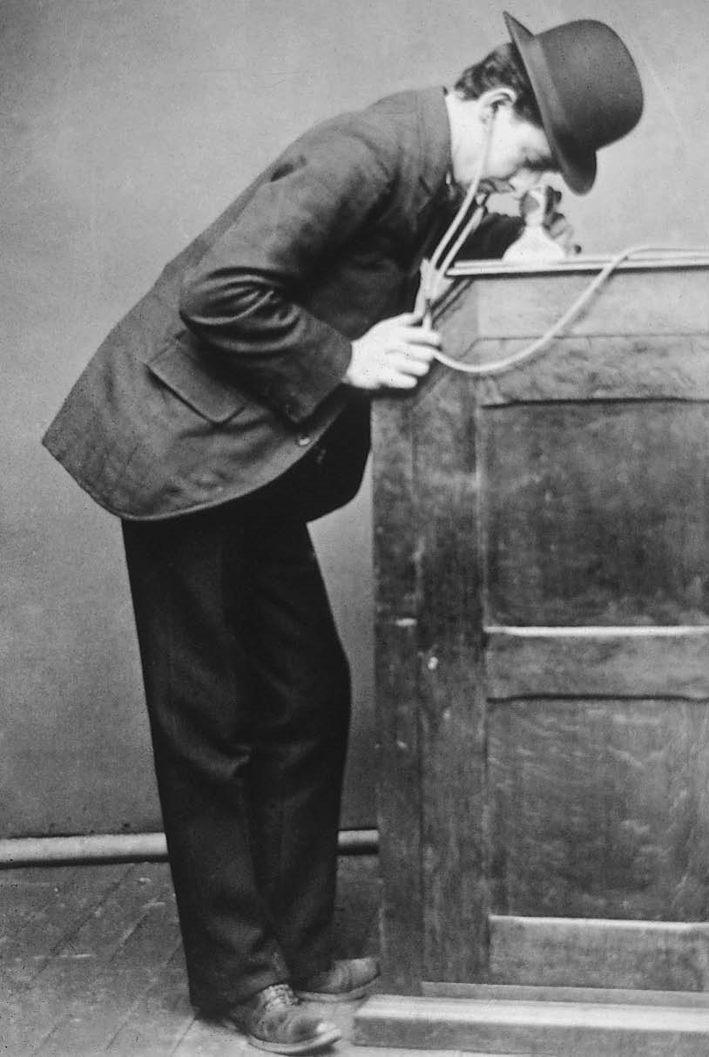

Courtesy of the Edison National Historic Site

Edison’s peepshow Kinetoscope, featuring ear tubes for sound, entertained one customer at a time.

These Kinetoscope arcades were modeled on phonograph parlors that had proved successful for Edison several years earlier. In the phonograph parlors, customers listened to recordings through individual ear tubes, moving from one machine to the next to hear different recorded speeches or pieces of music. The Kinetoscope parlors functioned in a similar way. More interested in the sale of Kinetoscopes (for roughly $250 apiece) to these parlors than in the films (which cost approximately $10 to $15 each) that would be run in them, Edison refused to develop projection technology, reasoning (quite correctly) that if he made and sold projectors, then exhibitors would purchase only one machine— a projector—from him instead of several.

Exhibitors, however, wanted to maximize *their* profits, which they could do more readily by projecting a handful of films to hundreds of customers at a time (rather than to one at a time) and by charging 25 to 50 cents for admission. About a year after the opening of the first Kinetoscope parlor in 1894, showmen such as Louis and Auguste Lumiere, Thomas Armat and Francis Jenkins, and Orville and Woodville Latham (with the assistance of Edison’s former assistant, Dickson) perfected projection devices that were used in vaudeville houses, legitimate theaters, local town halls, makeshift storefront theaters, fairgrounds, and amusement parks to show films to mass audiences.

MASS PRODUCTION, MASS CONSUMPTION

#### A Public Spectacle

With the advent of projection (1895–1896), the motion pictures became the ultimate form of mass consumption. Previous audiences, of course, had viewed spectacles en masse at the theater, where vaudeville, popular dramas, musical and minstrel shows, classical plays, lectures, and slide and lantern shows had been presented to several hundred spectators at a time. But the movies differed significantly from these other forms of entertainment that depended on either live performance or (in the case of slide and lantern shows) the active involvement of a master of ceremonies who assembled the final program.

Although exhibitors regularly accompanied movies with live acts, the substance of the movies themselves was mass-produced, prerecorded material that could easily be reproduced for audiences by theaters, with little or no active participation on the audience members’ part. Even though early exhibitors shaped their fi lm programs by editing them together in whichever ways they thought would be most attractive to audiences or by accompanying them with lectures, their creative control remained limited. What audiences came to see was the technological marvel of the movies: the lifelike reproduction of the commonplace motion of trains, waves striking the shore, and people walking in the street, and the magic made possible by trick photography and the manipulation of the camera.

With the advent of projection, the viewer’s relationship with the image was no longer private, as it had been with peepshow devices such as the Kinetoscope and the Mutoscope, which was a similar machine that reproduced motion by means of successive images on individual photographic cards instead of images on strips of celluloid. In 1896, it suddenly became public—an experience that the viewer shared with dozens, scores, and even hundreds of others. At the same time, the image that the spectator viewed expanded from the minuscule peepshow dimensions of 1 or 2 inches (in height) to the life-size proportions of 6 or 9 feet. The spectator was no longer a Peeping Tom looking guiltily through a keyhole but a voyeur whose activity was shared (and thus semiauthorized) by a larger public.

#### Middle-Class Amusements

F rom 1896 to roughly 1905, when the nickelodeon era began, the audience that went to the movies (in the United States, at least) was the same more or less middle-class audience that had previously gone to vaudeville shows, variety theaters, and amusement parks. Indeed, the movies became variety acts of a sort, which played alongside live acts in places that provided a broad spectrum of different kinds of popular entertainment. Although the audiences consisted of all socioeconomic classes, the cost of admission tended to exclude the lower

classes, as did the length of the program, which in vaudeville theaters was 2 hours or more. As a result, working-class laborers, who worked (ca. 1900) 60 hours a week or more and earned less than 4 dollars a week, could only afford to attend on occasion.

The films mirrored the variety of contexts in which they were presented. Shown primarily in vaudeville houses until 1905, motion pictures appealed to audiences as attractions, a series of acts within the larger act of motion pictures, which was itself often only one of eight other variety acts. The kinds of films shown were *actualities* (documentaries, views of famous or distant places), recorded vaudeville acts, excerpts from popular plays, phantom rides (films shot from the front of moving vehicles), and trick films, which used the techniques of slow motion, reverse motion, substitution, and multiple exposure to perform tricks or acts of “magic.”

Scholars of early cinema such as Tom Gunning describe this cinema of attractions as essentially an exhibitionist cinema. As attractions, films with self descriptive titles like *The Execution of Mary Queen of Scots* (1895) or *Electrocuting an Elephant* (1903) presented or exhibited spectacles for viewers to admire. Strongmen such as Eugene Sandow flexed their muscles for the camera, and exotic dancers such as Fatima performed for the camera. Certain erotic films, such as *From Showgirl to Burlesque Queen* (1903), relied on a more traditional form of exhibitionism, as women undressed before and looked flirtatiously at the camera.

Early, pre-1906 cinema stressed showing rather than telling. Most films made in this period were actualities, which outnumbered fiction films until roughly 1906, when the percentage of story films began to increase dramatically and actualities became less and less popular. The shift from one kind of cinema to the other took place rapidly. By 1908, 96 percent of all American films told stories. The institutionalization of narrative as the primary category of American motion picture production marked the beginning of another stage in the development of the cinema as an institution. It was accompanied by a significant change in film exhibition.

#### The Nickelodeon: A Collective Experience

Starting in 1905, theaters devoted exclusively to the showing of motion picture films began to spring up in virtually every city in the country. Referred to as “nickelodeons” because the price of admission was initially only a nickel— this figure subsequently rose to 10 cents—these small, 200-seat theaters were quickly installed in or near shopping or entertainment districts in former stores that were converted, often in an extremely makeshift way, to movie theaters. The low cost of admission and the abbreviated length of the programs attracted a new class of patrons, whom previous (and more expensive) forms of popular entertainment had ignored—the working classes.

Previously, working-class amusements had been confined to the home, the church, the saloon, or the social club. Nickelodeons drew the poorer elements of society, including recent immigrants, out of the ethnic social life associated with their local neighborhoods into a more diversified public space, where members of different classes and religions were transformed into a community of moviegoers. At the same time, these theaters continued to attract members of the middle-class audience that had earlier seen movies in vaudeville theaters.

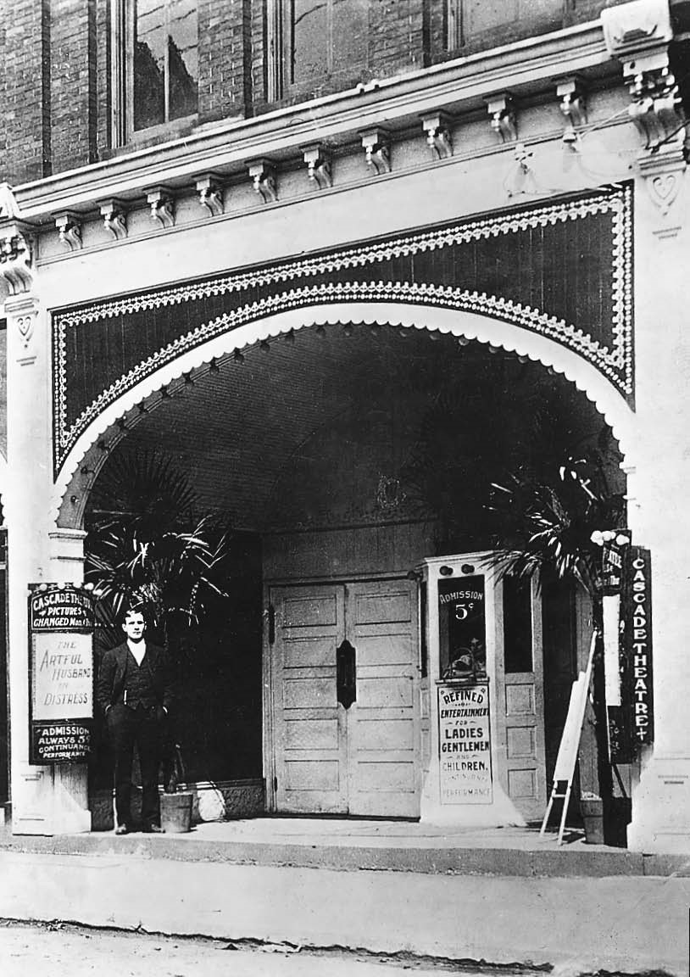

Author’s collection

The exterior of a typical nickelodeon, the Cascade Theatre in New Castle, Pennsylvania (ca. 1903).

Although the nickelodeons were never the melting pot of American democracy that certain historians have claimed, by 1910 they did provide the 26 million Americans who attended over 10,000 nickelodeons each week a common entertainment program. For the first time, millions of Americans from different backgrounds watched the same films and thus shared a collective experience as an invisible community. As the popularity of the nickelodeons increased and the movie going audience expanded, these theaters began to serve as the site for the creation of a homogeneous, middle-class American culture.

A s a writer for *Harper’s* magazine noted on visiting a nickelodeon in 1913, once the various members of the ethnically, socially, and economically diverse audience had taken their seats, they became part of a single crowd, caught up in the dreamlike images on the screen. This utopian ideal of a classless (or universally middle-class) community of spectators may never have been realized, but its potential was certainly there in the form of an institution of mass production and mass exhibition that was itself national in scope.

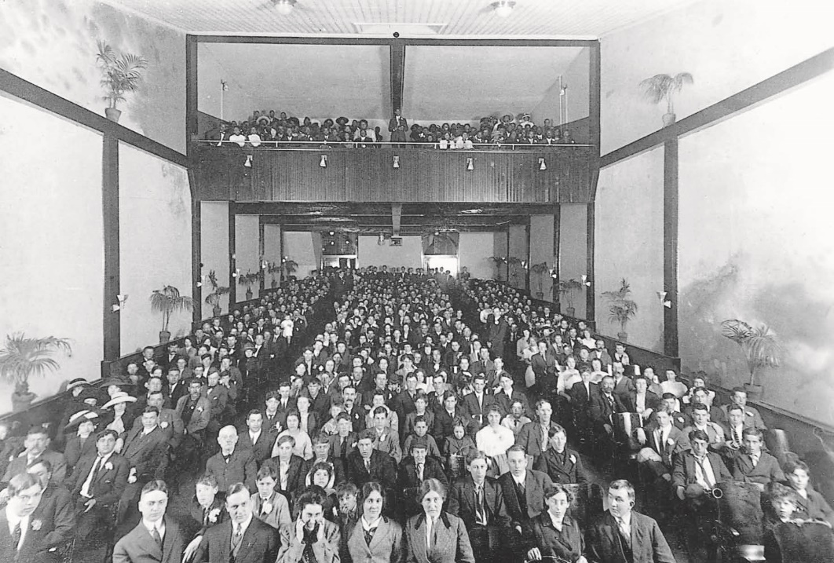

Author’s collection

Moviegoing as a social institution. The opening night audience at the (segregated) Rex Theater in Hannibal, Missouri, on April 4, 1912. Whites sat in the orchestra while blacks were seated in the balcony.

#### Cleaning Up: The Benefits of Respectability

The fi lm industry was becoming more and more stabilized. In 1908, the major fi lm producers banded together to form the Motion Picture Patents Company (MPPC), which sought to control all aspects of motion picture production, distribution, and exhibition (see Chapter 4, “The Studio System”). Shortly after the formation of the MPPC, exhibitors and fi lm producers sought to expand the market of habitual moviegoers to include greater and greater numbers of those who had previously attended only “high-class” amusements, such as the theater and vaudeville.

However, in December 1908, the mayor of New York City ordered that all nickel theaters be closed, arguing that they posed a “threat to the city’s physical and moral well-being.” Exhibitors and members of the MPPC responded almost immediately with a campaign to improve the content of motion pictures and the conditions of theaters. At the same time, exhibitors consciously began to court middle-class customers by becoming more “respectable.” They provided half-price matinees for women and children, they upgraded the quality of the physical structure of the theaters, they eliminated lower-class elements such as ethnic films and foreign-language sing-alongs, and they raised prices.

Producers joined the program to uplift the movies by making films that appealed to a higher class of clientele. They engaged in self-censorship to control any content of motion pictures that might prove offensive to middle-class tastes. And they voluntarily submitted their films to the national Board of Censorship (an independent body of censors) for review. In an attempt to appeal to middle-class sensibilities, they drew more and more on the classics. Prior to 1908, the source material for movies had come from newspaper headlines, vaudeville and burlesque routines, political cartoons, fairy tales, and popular songs. Between 1907 and 1911, however, Vitagraph released more than fifty films that were based on literary, historical, or biblical sources. Filmmakers began to adapt the works of Edgar Allan Poe, Charles Dickens, Emile Zola, Leo Tolstoy, Victor Hugo, and William Shakespeare.

SPECTACLE AND STORYTELLING:

FROM PORTER TO GRIFFITH

#### The Camera as Recorder

The bourgeoisification of the movies involved considerably more than merely upgrading motion picture content from strongmen flexing their muscles to Shakespeare. In adapting more complex story material to the screen, filmmakers were forced to upgrade their own abilities as storytellers. While early American cinema had been exhibitionist in nature, satisfied with showing attractions, subsequent (post-1908) American cinema became more and more intent on the perfection of narrative skills. Mere theatrical display proved less and less capable of conveying complex character psychology or intricate narrative complications. Middle-class audiences who had grown up with the highly involved plots and fascinating characters of authors such as Dickens began to demand more sophisticated fi lm narratives than had their predecessors. Film directors like D. W. Griffith, who carefully crafted narrative personae for themselves, provided these new audiences with the kinds of narratives with which they were familiar in the theater or in literature.

Edwin S. Porter, the major filmmaker associated with early American cinema, epitomized the presentational style of pre-Griffith cinema. Intent on a theatrical style of spectacle, Porter composed his narratives out of a succession of separate attractions. In one of his most famous films, *The Life of an American Fireman* (1903), Porter showed the fireman’s dramatic rescue of a mother and her baby from the second story of a burning building. In the final version of the fi lm, Porter presented the action of the rescue as he had originally filmed it—in two successive shots. Filmed at two separate times as two separate spectacles staged in two separate spaces, the event remained that way for the audiences who saw it in 1903.

In the first shot, audiences saw the interior of a smoke-filled room: the fireman enters, rescues the woman, and returns a few moments later to rescue the infant. In the next shot, audiences saw the exterior of the building: the fireman enters, rescues the woman by carrying her down a ladder, and then, informed that her child is still in the room, returns to rescue the baby. In other words, Porter showed the same action from two different perspectives successively rather than cutting back and forth from the interior to the exterior of the building to follow the unfolding of the drama as it might have been told by a storyteller more intent on suspense and the act of narration itself.

#### The Camera as Narrator

Primitive cinema presented events but provided little or no reading of them. Events spoke for themselves without the intervention of a narrator or narrating presence that attempted to read or interpret them for the audience. The cinema of Griffith (and later) actively narrated events, shaping the audience’s perception of them. This was accomplished in a variety of ways, but chief among them, for Griffith at least, was the device of parallel editing, which involves cutting back and forth from two (or more) simultaneous events taking place in separate spaces.

T om Gunning described the parallel editing in Griffith’s *The Drive for Life* (1909), which cuts back and forth between a man who discovers that the woman he has jilted has sent a box of poisoned chocolates to his fiancée, and his fiancée, who is about to eat one of the pieces of candy. As the fiancée picks up a piece of chocolate and is about to eat it, Griffith cuts away, in mid-gesture, to her lover, speeding to her in his car to warn her of her danger. The suspense editing repeatedly interrupts her action, returning to show her being distracted by her sister, dropping the candy, or kissing it. Each time the fi lm cuts away from her as she is about to eat the poisoned candy, the presence of Griffith as a narrator can be dramatically felt.

At the same time, Griffith used editing to contribute to the psychological development of his characters, giving the audience a sense of what they are thinking. In *After Many Years* (1908) he cut from a wife to the object of her thoughts—her shipwrecked husband. Other edits were used to explain the motivation or the behavior of his characters. In *Salvation Army Lass* (1908), Griffith cut away from a burglar on his way to commit a crime to a shot of his girlfriend, still lying on the ground where he had left her after rejecting her pleas that he not go on the job. When Griffith cut back to the burglar, who then changes his mind about going ahead with the crime, he deftly conveyed to the audience the reasons for the burglar’s change of heart.

#### The “Feature” Film

With the emergence of a cinema of narration, which replaced that of monstration or showing, classical Hollywood cinema took one step further toward the institutionalization of the cinema as an American pastime. As narratives became more complex, the 1000-foot, one-reel (10- to 15-minute) format of the motion picture, which had only recently become an industrywide standard in 1908, became more and more restrictive. Critics in the trade magazine *Moving Picture World* observed that “the filming of some great opera or a popular literary or dramatic or historical subject requires more than a reel” and suggested that the longer the pictures, the more exhibitors could charge audiences to see them.

Multiple-reel “feature” films from abroad, such as *Dante’s Inferno* (five reels, Italy, 1911), *Queen Elizabeth* (four reels, France, 1912), *Quo Vadis* (eight reels, Italy, 1913), and *Cabiria* (ten reels, Italy, 1914) were showcased in large, firstclass legitimate theaters, which charged from 25 cents to a dollar for tickets. The financial success of these multiple-reel European films prompted American producers to release longer and longer films, including Griffith’s biblical spectacle, *Judith of Bethulia* (four reels, 1914), his adaptation of Poe’s “The Telltale Heart” and “Annabel Lee,” *The Avenging Conscience* (six reels, 1914), and his historical epic, *The Birth of a Nation* (twelve reels, 1915).

*The Birth,* which sustains an intricate narrative for 3 hours of screen time, held audiences spellbound. One of Griffith’s assistants, Karl Brown, reported his reactions to seeing the fully assembled fi lm for the first time on opening night. “What unfolded on that screen was magic itself. I knew there were cuts from this and to that, but try as I would, I could not *see* them. . . . All I knew was that between the ebb and flow of a broad canvas of a great battle, now far and now near, and the roaring of that gorgeous orchestra banging and blaring battle songs to stir the coldest blood, I was hot and cold and feeling waves of tingling electric shocks racing all over me.”

*The Birth* ran for 44 consecutive weeks at the Liberty Theater in New York City, where reserved-seat tickets were sold at the unprecedented price of 2 dollars. Its success transformed the nature of American fi lm production and exhibition. It marked the end of “the lowly nickelodeon storefront theater, with its tinny honky-tonk piano and its windowless, foul-air smelliness” and introduced “the grandeur of a great auditorium with a great orchestra and a great picture that ran for three hours and filled an entire evening with thrills and excitement in a setting of opulent luxury such as the great masses of working people had never dreamed possible for them.”

*The Birth* was notorious for other reasons as well, chief among them its racist agenda. *The Birth* illustrated the enormous power of the motion picture medium to communicate ideological arguments. Griffith’s melodramatic retelling of the story of the Civil War and Reconstruction posited a villain. That villain was the African American (and the white politicians in the North who were determined to “overthrow civilization in the South” and to “put the white South under the heel of the black South”). For Griffith, the birth of the nation depended on the subjugation of the African American and the restoration of white privilege. If *The Birth of a Nation* marked the birth of classical Hollywood cinema, then that birth was grounded in white racism.

PRESENTING . . . THE MOVIE PALACE

#### “Gardens of Dreams”

T he advent of multiple-reel, feature-length films was accompanied by a dramatic change in motion picture presentation as the uncomfortable, small, makeshift nickelodeons gave way to luxurious movie palaces and other large theaters especially built for the showing of motion pictures. Though the majority of movie theaters built in the 1910s and 1920s tended to be modest in size, seating from 500 to 800 spectators, more and more large movie palaces, seating from 1500 to over 6000 spectators, were built in urban areas. In contrast to the congestion and oppressive sense of city life experienced by urban residents outside the theater, inside the typical movie palace customers enjoyed the luxury of spacious, stately surroundings and a staff of obliging theater attendants who sought to answer their every need.

Movie palaces, boasting a palatial decor that ranged from the classical to the exotic, provided “an acre of seats in a garden of dreams.” Contemporary interior decorator Harold Rambusch declared, in 1929, that “in our big modern movie palaces are collected the most gorgeous rugs, furniture and fixtures that money can produce. No kings or emperors have wandered through more luxurious surroundings. In a sense, these theatres are social safety valves in that the public can partake of the same luxuries as the rich.”

#### The Great Showmen

T he era of the movie palace began in 1913 with the opening of the 2460-seat Regent, “the first de luxe theatre built expressly for showing movies in New York.” Shortly after the Regent opened, showman S. L. Rothapfel was hired to manage it. He made it the premier motion picture theater in the world. Like the movie palaces that followed it, the Regent featured an organ, an orchestra, a chorus and/or opera singers, ushers to show patrons to their seats, and a lavish atmospheric interior adorned with gilt.

Rothapfel, or “Roxy” as he was called by his associates, was subsequently lured away from the Regent, which was located uptown at 116th Street and Seventh Avenue, to operate the 3500-seat Strand (1914), which was downtown at Broadway and 47th Street. The *New York Times* reviewed opening night, was impressed by the neo-Corinthian decor and the plush seats, and compared the experience to “going to a Presidential reception.” Roxy later lent his flair for extravagant motion picture presentation to the 1900-seat Rialto when it opened on Times Square in 1916.

By this time, the entertainment program of the movie palace had expanded to include (in addition to the theater orchestra’s overture and musical accompaniment of the silent feature) dancers, opera singers, and other performers in live skits. The fi lm program had also evolved to consist of not only the feature fi lm but a newsreel and a comedy short as well. In fact, the feature presentation tended to occupy only about 68 percent of the entire program.

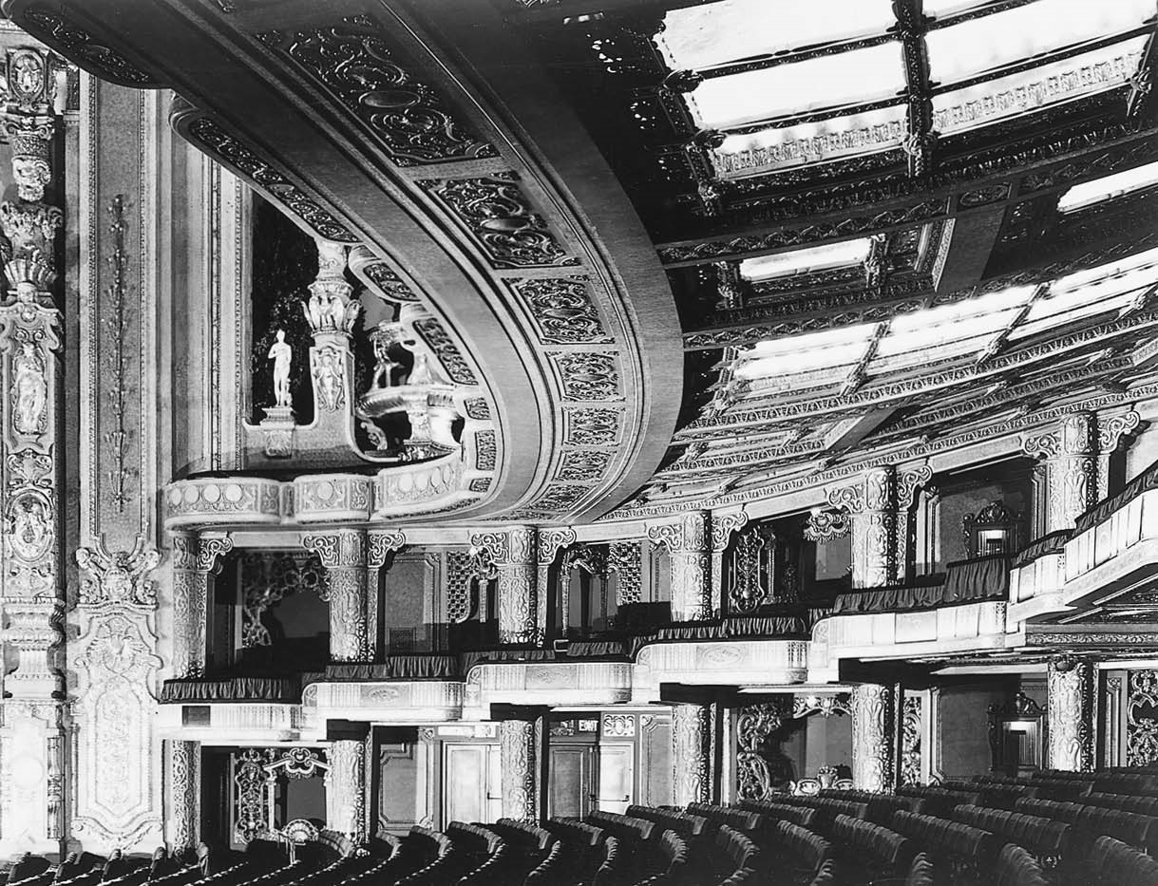

Author’s collection

The interior of a typical movie palace, the Brooklyn Paramount.

Roxy continued to provide bigger and better shows in a series of other New York theaters. He took over the management of the 2100-seat Rivoli (built in 1917) and of the 5300-seat Capitol (built in 1919, managed by Roxy in 1920), and then of his own 6200-seat Roxy Theatre (1927). By the time he built the Roxy, the art of exhibition had developed into a science. Not only were uniformed ushers and other theater personnel drilled in their duties like military cadets, but spectators became part of this streamlined system of efficiency as well. As Richard Koszarski points out, “Each seat in the Roxy was wired to a central console so the house staff could immediately direct patrons to new vacancies.” In Los Angeles, impresario Sid Grauman followed Roxy’s example, launching a series of movie palaces that were each more lavish than the other. While Roxy gave his audiences an entertainment program consisting of a variety of different live acts to accompany the fi lm, Grauman provided a “Prologue,” a show thematically related to the motion picture. His theater empire began with the Million Dollar Theatre (2100 seats) in 1917, then the Egyptian (1900 seats) in 1922, the Metropolitan (3485 seats) in 1923, and the Chinese (2500 seats) in 1927. As the names “Egyptian” and “Chinese” suggest, a number of movie palaces of the 1920s adopted exotic architectural styles, employing Oriental, Hindu, Italian, Persian, Moorish, or Spanish decor to create a romantic atmosphere in which audiences could consume onscreen fantasies.

Other major cities, such as Chicago, built movie palaces of their own. Theater magnates A. J. Balaban and Sam Katz, following the major routes of urban mass-transit lines, put their theaters within reach of a growing urban middle class, building the 2400-seat Central Park Theatre in 1917, both the 4700-seat Tivoli Theatre and the 3900-seat Chicago Theatre in 1921, and the 4000-seat Uptown Theatre in the mid-1920s. In addition to mighty Wurlitzer organs, full orchestras, and live stage shows, Balaban & Katz theaters provided patrons with “free child care, attendant smoking rooms, foyers and lobbies lined with paintings and sculpture, and organ music for those waiting in line.” A staff of nurses and mother’s helpers took care of the young children of patrons in the theater basement, which was equipped like a neighborhood playground with slides and sandboxes. At the same time, starting in 1921, Balaban & Katz theaters also had air conditioning, which gave them a crucial advantage over their competition throughout the summer months.

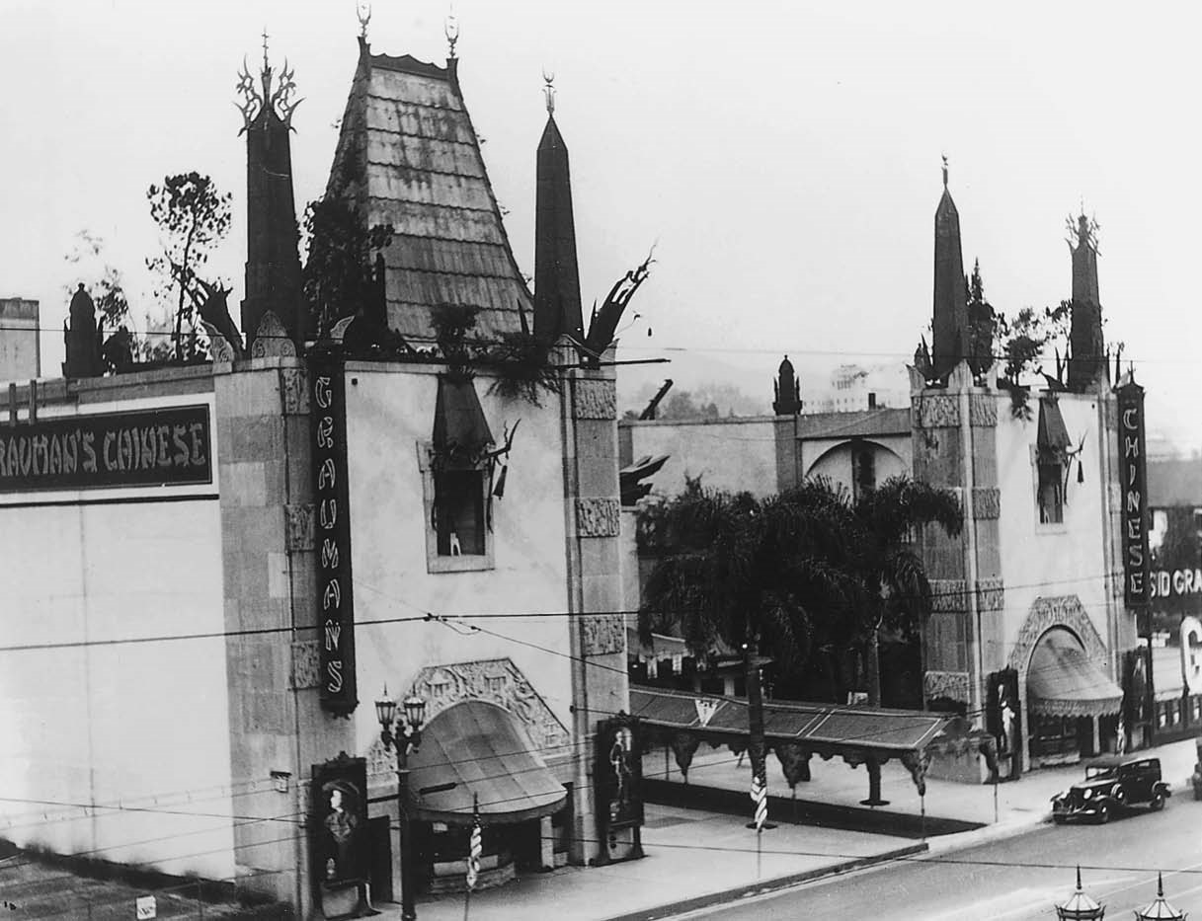

Author’s collection

Grauman’s Chinese Theater in the late 1920s.

Noting the success of the Balaban & Katz theaters in Chicago, Paramount joined forces with that organization and put Sam Katz in charge of all Paramount theaters. As a result, the model for movie palaces developed by Balaban & Katz found widespread adoption in the Paramount theater circuit. It quickly spread to the circuits of other major studios as well, becoming the standard used by the fi lm industry as a whole. With the construction of theaters especially designed for the exhibition of motion pictures, the shift from one-reel films to the new phenomenon of the feature-length fi lm that presented narratives and characters as sophisticated as those found in other typically middle-class forms of representation, and the development of a habitual, moviegoing audience composed of a broad spectrum of the general public, the basic elements of the cinematic institution fell into place.

AN EVOLVING INSTITUTION

The cinema began as a technological marvel, as the latest invention from Thomas Edison, the “wizard of Menlo Park.” The early cinema of the prenickelodeon days evolved from a primitive cinema of attractions into a modern cinema of compelling characters, engrossing stories, and hypnotic illusionism. Throughout the 1920s, the presentation of motion pictures retained its origin in the world of amusement parks, vaudeville, and burlesque. The movie palaces are themselves spectacles that frequently overwhelm the films shown in them. House orchestras and stage shows also foster an air of variety, as does the presence of newsreels, comedy shorts, and other filmed material that rounds out the program. Yet the feature fi lm holds its own among these other attractions. Its ability to give expression to its characters’ emotions, to explore their psyches, to trace their pursuit of their goals—in short, to tell their stories—has evolved to a point of near perfection. The coming of sound, color, widescreen, and stereo sound would add somewhat to the feature film’s expressive capabilities but would not profoundly alter classical Hollywood cinema’s ability to function as an efficient system of storytelling. Today’s filmmakers draw on essentially the same set of stylistic practices and narrative techniques as those forged by Griffith and others during the period in which the fundamental elements of the feature fi lm were established.

Other features of the cinematic institution, however, have been dismantled. The 1920s witnessed the creation of a general moviegoing public that habitually patronized the nation’s cinemas. For over twenty years, from 1929 to 1949, more than 80 million Americans went to the movies every week. In 2010, the average weekly attendance was only 25.8 million. The age of the nickelodeon gave way to that of the movie palace in the 1910s and 1920s. In the 1960s, the gigantic movie palaces of the past gave way to the new nickelodeons of the present—to small, minimally decorated multiplexes and mall cinemas. The Roxy was torn down in 1961. Radio City Music Hall, though still standing, ceased showing motion pictures on a regular basis in 1978. Today, an increasing number of viewers watch movies in a non-theatrical setting—at home, on their DVD players or streamed live by Netflix to their computers, PlayStations, or Blu-ray players or on the go, on their laptops, netbooks, cell phones, or iPads. The cinematic institution of Hollywood past has disappeared. It slowly transformed itself, from the 1950s to the present, into a new institution designed to serve the different needs of contemporary audiences and an ever-changing, modern motion picture marketplace.

The chapters that follow are designed to provide an in-depth portrait of the cinematic institution in its heyday. They look at its stylistic foundations in classical Hollywood’s stylistic and narrative practices, at its industrial roots in the studio system, and at its basic economic underpinnings in the star and genre systems. The goal is not only to draw a map of the terrain of the institution of American cinema, but also to recover for today’s generation of moviegoers some sense of the *experience* that previous generations had when they went to the movies.